The Tribute XXVI Committee expresses its sincere appreciation to the following businesses, organizations, and individuals for their generous support and sponsorship:
  GENERALS CLUB ($1000+)
  Kirtland Federal Credit Union
  TriWest Healthcare Alliance
  CHIEFS CLUB ($500-$999)
  Sandia Area Federal Credit Union
  ALL-VOLUNTEER FORCE ($10-$499)
  Dorothy Abbott
  Christin Barden
  Olive Baker-Brown
  Col Leymoyne Blackshear
  Blue Star Mothers of Valencia County
  Katherine Kerns
  Marlene Mathis
  Eva Morgan
  Marian Moorman
  Margaret Schmidt
  Sally Uebelacker
  In Memory Of:
  All Military Nurses, by Josefita Swazo
  Jason Ainores, USMC, by Glynda Greene
  Louis H. Bernasconi & Tommy E. Gist, USAF, by Sara Bernasconi
  Gloria Dempsey-Stephens, by Barbara Pickering
  Margaret McInernery, Army Maj, by Patricia Kelly
  Maggie Toledo, USN LCDR, by Debra Estrada
  Felix Trujillo, by Alyce Trujillo
  Col Horace S. Villars USMC, by Emily Zander
  In Honor Of:
  Air Force Nurses, by Shirley McGuire
  Mary Cox & Diana Wong, by Terry Barrett
  Mary Cox, by Angie Lopez
  Mary F. Fiser
  Olen Kee, Navy PO2, by Henrietta K. Bushman
  Tonya R. (Sampson) Kramer, by Gloria Chavez-Sampson
  PURSE AUCTION DONATIONS
  Cassie Ringham-Chavez, Miche Bag & Scentsy Sales Rep
  Hospice of the Sandias
  Kelly Aldrich Photography (www.KellyAldrichPhotography.com)
  Judy Shaffer Jewelry
  Tribute XXVI Committee – TV & Kindle
  Vicky Rechkemmer, BeautiControl Consultant
  Women Veterans of New Mexico
  Christin Barden, Mary, Cox
  Shirley McGuire, Diana Wong
  DOOR PRIZE DONATIONS
  American Cancer Society
  Cassie Ringham-Chavez, Miche Bag & Scentsy Sales Rep
  Mary Cox
  Kelly Aldrich Photography (www.KellyAldrichPhotography.com)
  Kirtland Federal Credit Union
  Mary Arnholt (USAFR), Mary Kay Cosmetics
  New Mexico Veterans Memorial
  People Living Through Cancer
  Post 401 Ladies Auxiliary to the Veterans of Foreign Wars
  RE/MAX Alliance REALTORS/Catherine J. Cullen
  Tribute XXVI Committee
  Vicky Rechkemmer, BeautiControl Consultant
  Women Veterans of New Mexico
  TOTE BAG CONTRIBUTIONS
  American Cancer Society
  People Living Through Cancer
  RE/MAX Alliance REALTORS/Catherine J. Cullen
  Santa Fe National Cemetery
  Vicky Rechkemmer, BeautiControl Consultant

2011 Tribute Committee
Elaine Gonzales, MSgt, USAF (Ret) - Chair  Kelly Aldrich, Maj, USAFR  Rebecca Auringer, USAF (Ret)  Christin Barden, USAF Veteran  Gloria Chavez-Sampson, DoD Civilian  Mary Cox, USN Veteran  Debra Estrada, USN (Ret)  Yolanda Freeman, TSgt, USAF (Ret)  LuAnn Gadberry, DoE Civilian | Laurel Hull, USMC (Ret) - Emcee  Robert J. Liddy, Jr., DoD Civilian  Marlene Mathis, LCDR, USN (Ret)  Shirley McGuire, Lt Col, USAF (Ret)  Juanita Sanchez, USA/USAF Veteran  Ethel Tilley, DoD Civilian  Diana Wong, USAF Veteran  Kirtland AFB Top 3

Visit our website for event photos and information:
www.TributeToWomenInTheMilitary.org

Military Women in Action

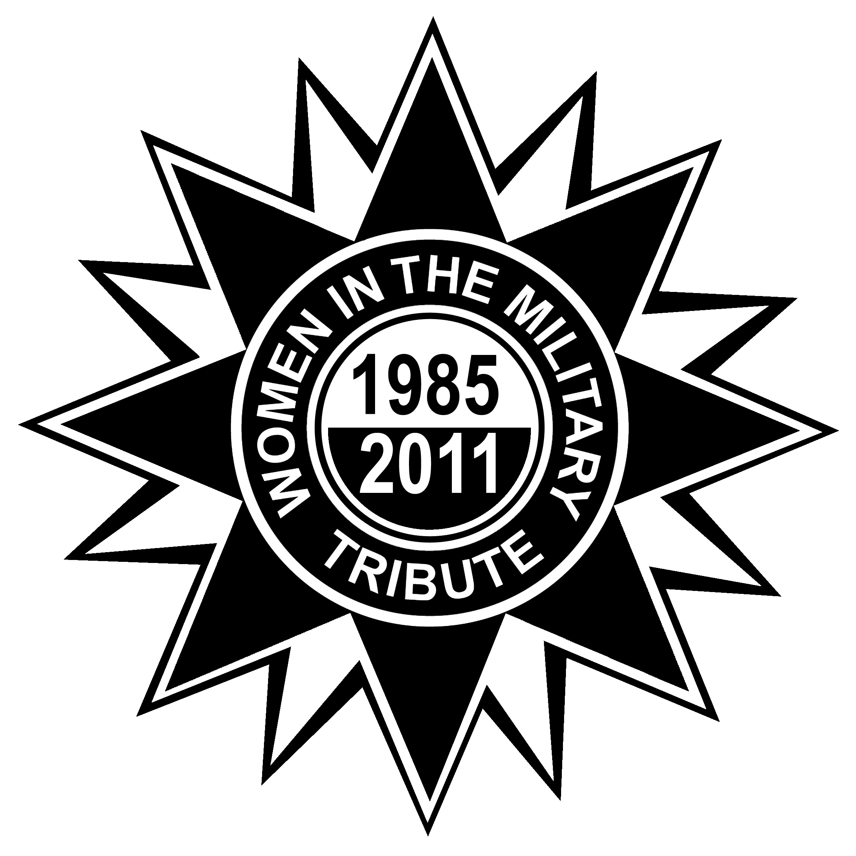

4 March 2011
Mountain View Club
Kirtland AFB, NM

SEQUENCE OF EVENTS
Morning Events:
Welcome Remarks
Presentation of Colors
National Anthem
Flag Song
Invocation
Introduction of Distinguished Guests
Native American Flute
Pueblo of Acoma Dance/Blessing
Seminars
Afternoon Events:
Introduction of Distinguished Guests
POW/MIA Presentation
Invocation
Guest Speaker
Lunch
Musical Entertainment
Poem
Scholarship Presentation
Silent Purse Auction Announcements
Closing Remarks

SHOSHANA N. JOHNSON
Former POW, Operation Iraqi Freedom

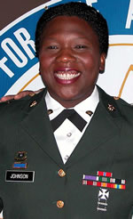
Former United States Army Specialist Shoshana N. Johnson is the first female Prisoner of War (POW) of Operation Iraqi Freedom, and the first black female POW in United States war history.

Ms. Johnson graduated in 1991 from Andress High School in El Paso, TX where she was a JROTC cadet. She attended the University of Texas at El Paso, and later joined the US Army in September 1998. She completed the US Army Basic Training Course at Ft. Jackson, South Carolina, and the Advance Individual Training, at Ft. Lee, Virginia.

A second-generation Army Veteran, Shoshana’s first military assignment was at Ft. Carson, Colorado. In February, 2003, at her second military assignment at Ft. Bliss, Texas, Specialist Johnson received orders to deploy to Iraq and to carry through her duties as a Food Service Specialist, (92G) with the 507th Maintenance Company, 552 Battalion 11th Brigade.

On March 23, during Operation Iraqi Freedom, she was in a convoy that was ambushed in the city of an-Nasiriyah. Specialist Johnson received a bullet wound to her ankle, causing injuries to both legs. She and five other members of the 507th Maintenance Company were captured and taken Prisoners of War. The ambush and its aftermath made world news headlines.

House raids conducted by US Marines in the city of Samarra, Iraq, resulted in the successful rescue of seven POWs on the morning of April 13. Six days later, Specialist Johnson, together with six former POWs, came back to a heroes welcome in the US with a cheering crowd of over 3,000 people.

Since her return to the United States, Specialist Johnson has received numerous awards, and recognition for her courage, valor, and service to the United States.

Specialist Johnson retired from the Army on a Temporary Disability Honorable Discharge on December 12, 2003. Her awards and decorations include the US Army Service Ribbon, Army Commendation Ribbon, National Defense Ribbon, Good Conduct Medal, Bronze Star Medal, Purple Heart Medal, and the Prisoner of War Medal.

She was born in the Republic of Panama to Panamanian parents Claude and Eunice Johnson. Ms. Johnson has one daughter, and currently resides in El Paso, Texas.

