The Tribute XXVII Committee expresses its sincere appreciation to the following:

Kirtland AFB Top 3
Vietnam Veterans of America, Inc. Chapter 318

Department of Veterans Affairs
Mountain View Club
Kirtland AFB Community and Partners

2012 Tribute Committee

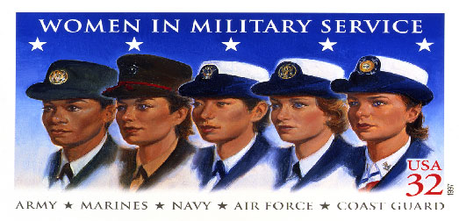
www.TributeToWomenInTheMilitary.org

TRIBUTE TO WOMEN IN THE MILITARY

Giving Back

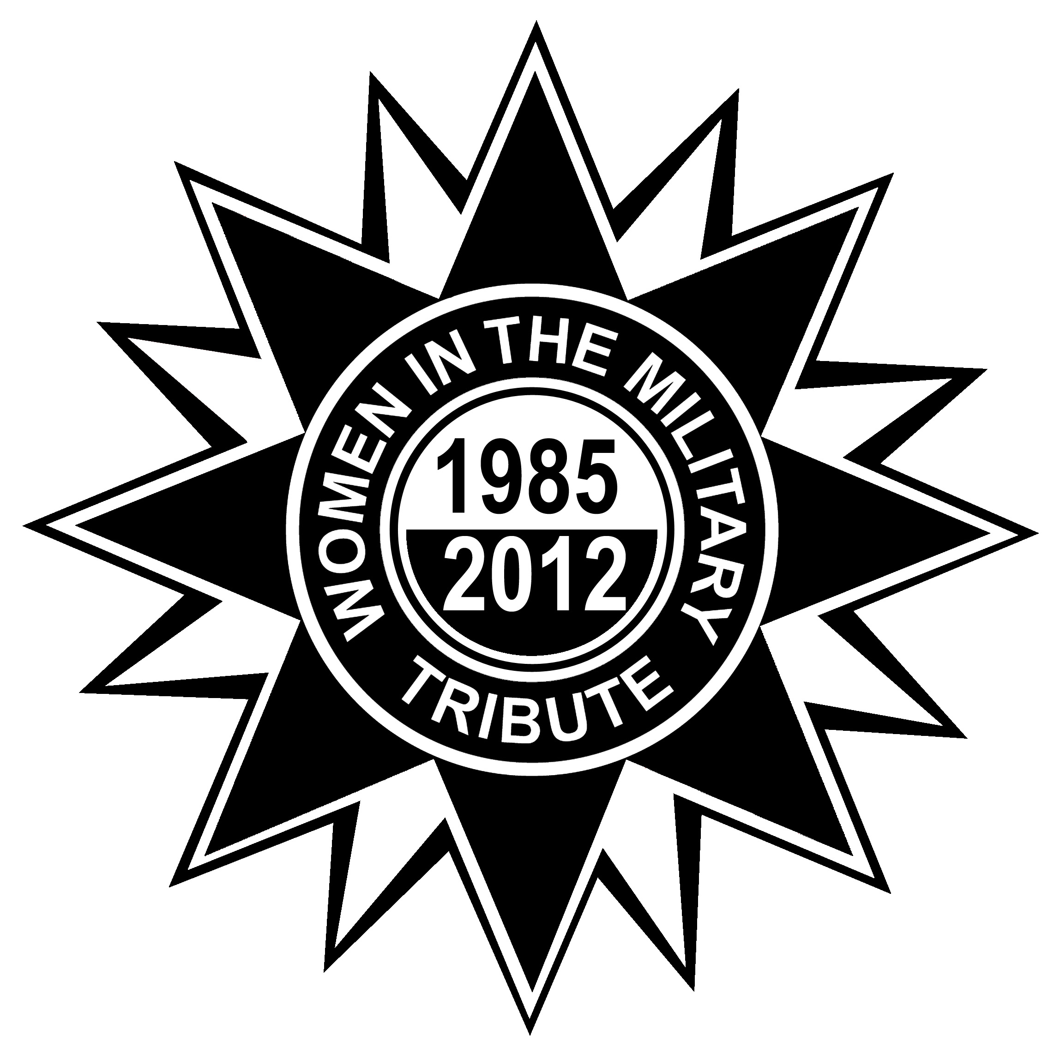

2 March 2012
Mountain View Club
Kirtland AFB, NM
BETTY MOSELEY BROWN, Ed.D
Associate Director of the Center for Women Veterans

Dr. Betty Moseley Brown assumed the position of Associate Director of the Center for Women Veterans on November 1, 2004. In this capacity, she advises and assists the Director of the Center for Women Veterans in planning, directing, managing, and coordinating programs and activities of the Center.
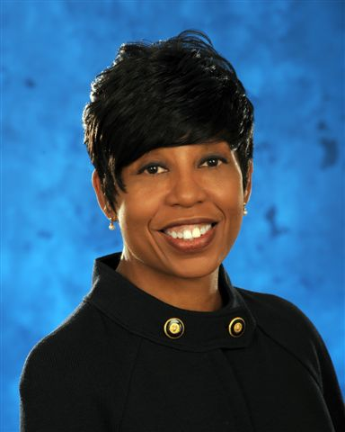
Dr. Moseley Brown’s passion for Veterans began during her United States Marine Corps service from 1978 – 1992. Her Department of Veterans Affairs (VA) career began at the San Diego Regional Office, where she was a Veterans Benefits Counselor and served as the Women Veterans Coordinator. She briefly left VA to work for the Department of the Navy.

Dr. Moseley Brown returned to VA in 2001, working in the Veterans Benefits Administration (VBA), Compensation and Pension Service and later working for the Associate Deputy Under Secretary for Policy and Program Management. She was VBA’s first outreach coordinator, coordinating outreach activities of five major programs and efficiently providing Veterans and dependents with information on benefits and services administered by VA.

As Associate Director, Dr. Moseley Brown serves as the facilitator for VA’s National Summit on Women Veterans’ Issues--a major training and outreach quadrennial event for women Veterans, women Veterans advocates, and other federal agencies that provide services to women Veterans, promoting transparent, interagency communication on issues impacting women in the military and women Veterans. She has also been instrumental in promoting national awareness of the contributions made by women who served in the military through multiple department-wide efforts, such as VA’s “Her Story” campaign and the “Faces Behind the War” DVD.

Dr. Moseley Brown has a Doctor of Education degree from the University of Sarasota. She is an avid Toastmaster, achieving the highest level in public speaking of Distinguished Toastmaster in January 2011. Dr. Moseley Brown is a 2004 Leadership VA (LVA) alumnus and 2009 graduate of the Federal Executive Institute.

Morning Events
Registration and Exhibits
Opening Ceremonies
Presentation of the Colors: Women Veterans of NM
National Anthem: SSgt Jessica Brown
Invocation: Chaplain, Jayme Allen
Introduction of Distinguished Visitors & Remarks
Paws and Stripes Presentation
Tribute to Women Veterans Slideshow
Tribute Poem by Juanita Sanchez
Enchanting White Doves by Paula Fay
Women’s Health, Health Screens, Exhibits

Afternoon Events
POW/MIA Ceremony
Invocation: Chaplain Robert Mansberger,
Lunch
Keynote Speaker: Dr. Betty Moseley-Brown
Remembrance Ceremony
Scholarship Presentation
Tribute Celebration ends

